**Process Sheet**

**Fabrication of Wooden Desktop Organizer using Woodworking Shop Machinery**

**Central Machining Facility – Wood Working Shop, IIT Delhi**

**Project Duration: 3 Hours | Evaluation: 300Points**

**Final Product : Wooden Desktop Organizer**

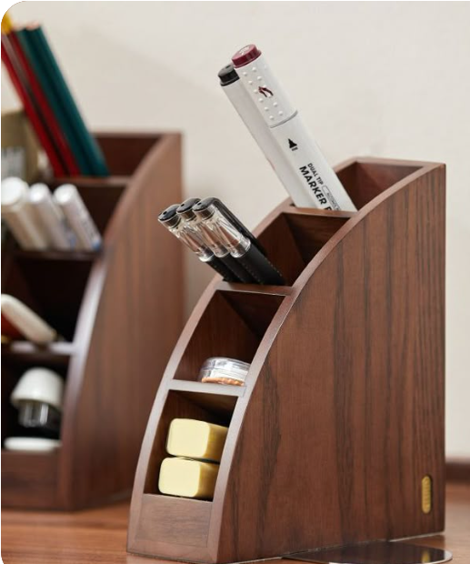

WOODEN DESKTOP ORGANISER

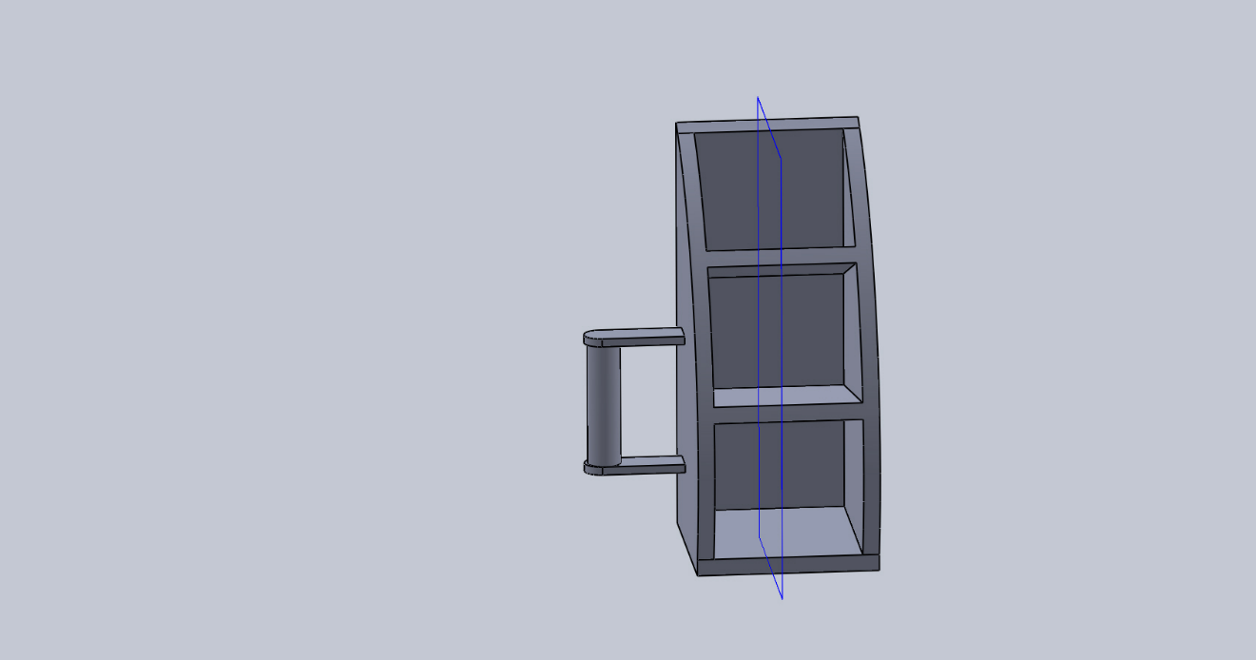

3D view of the product

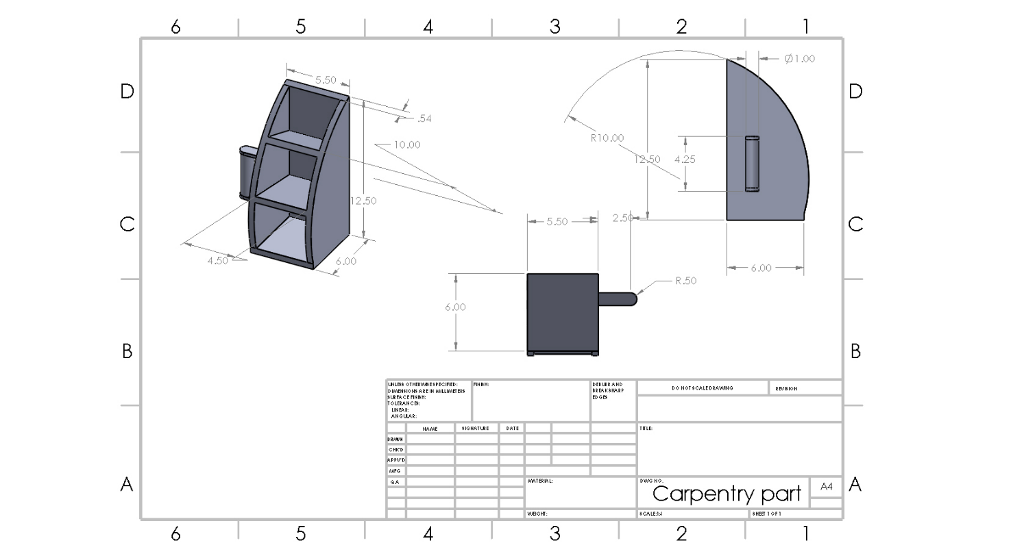

All dimensions are in inches

|  |  |
| --- | --- |
| **Part Name:** Wooden desktop organiser | **Material:** Wood |
| **Stock Size:** 30*10* 0.5 inch3, 4.5 dia rod | **Checked By:** |
| **Prepared By:** | **Date:** |

|  |  |  |  |  |  |  |
| --- | --- | --- | --- | --- | --- | --- |
| **S. No.** | **Machine** | **Operation Description** | **Machine/Tool required** | **Marks for Aesthetics & Functionality** | **Operation time (Min)** | **Credit** |
| 1. | **Hand Tools** | Measuring and marking the dimensions | Steel Rule  Scriber  Try Square | 50% | 20 | 30 |
| 2. | **Circular Saw** | Side walls and slot of the box  (Straight, Angular Cutting) | Circular saw/ Mitre saw / Table Saw / Router + Table saw | 50% | 35 | 60 |
| 3. | **Belt/Disc Sander** | Surface finish for the cut parts | Disc polishing / Belt Polishiong | 50% | 20 | 30 |
| 4. | **Lathe** | Turning 4.5 to 1 inches | Lathe / Single point cutting tool | 50% | 35 | 60 |
| 5. | **Jigsaw** | Giving radius of curvature to side walls | Jigsaw | 50% | 30 | 50 |
| 6. | **Fabrication** | Joining of parts to fabricate final part | Hand tools, Nails, Adhesives | 50% | 40 | 70 |

\***For measurement, Steel rulers and hand Tools are used.**

**Learning Outcomes**

* Proper use of marking and hand tools
* How to use different types of saws
* Finishing of wooden pieces
* Turning in the lathe
* Fabrication and joining of wooden parts

Student Signature: ____________________