**PROCESS SHEET**

|  |  |
| --- | --- |
| **Part Name:** Motor Coupler Shaft | **Material:** Mild Steel |
| **Stock Size:** 25mm dia. & 150mm length | **Checked By:** |
| **Prepared By:** | **Date:** |

|  |  |  |  |  |  |
| --- | --- | --- | --- | --- | --- |
| **S. No.** | **Machine** | **Operation Description** | **Machine/Tool required** | **Operation time (Min)** | **Credit** |
|  | Lathe | Machine and workpiece set up | Lathe | 15 | 30 |
| 1. | Facing the Stock piece. | Lathe / Single point cutting tool | 10 | 30 |
| 2. | Turning of the piece from 25mm dia. to 15mm dia. | Lathe / Single point cutting tool | 30 | 70 |
| 3. | Turning of the w/p from 15mm dia. to 8mm dia., 0mm to 20 mm in length. | Lathe / Single point cutting tool | 20 | 50 |
| 4. | Turning of the w/p from 15mm dia. to 12mm dia., 20mm to 48mm in length. | Lathe / Single point cutting tool | 15 | 50 |
| 5. | Grooving of the w/p from 12mm dia. to 9mm dia., 21.5mm to 23mm in length. | Lathe / grooving tool | 15 | 40 |
| 6. | Turning of the w/p from 15mm dia. to 11 mm dia., 68mm to 94 mm in length. | Lathe / Single point cutting tool | 15 | 40 |
| 7. | Turning of the w/p from 15mm dia. to 8mm dia.(approx.), 94mm to 110 mm in length. | Lathe / Single point cutting tool | 30 | 50 |
| 8. | Threading M8 | Lathe/ M8 threading Mold | 20 | 30 |

\***For measurement, Vernier Calipers are used.**

**Learning Outcomes**

* Proper use of marking and hand tools
* Workpiece alignment
* How the feed and depth of cut are provided
* Facing
* Turning
* Step turning
* Grooving
* Threading

Student Signature: ____________________

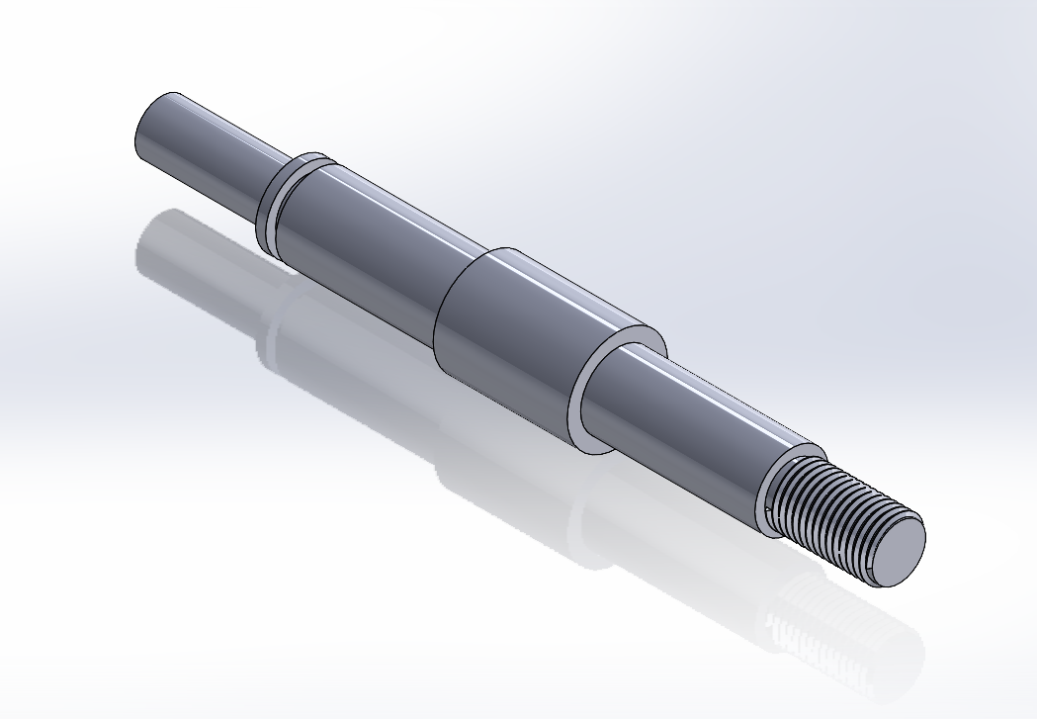

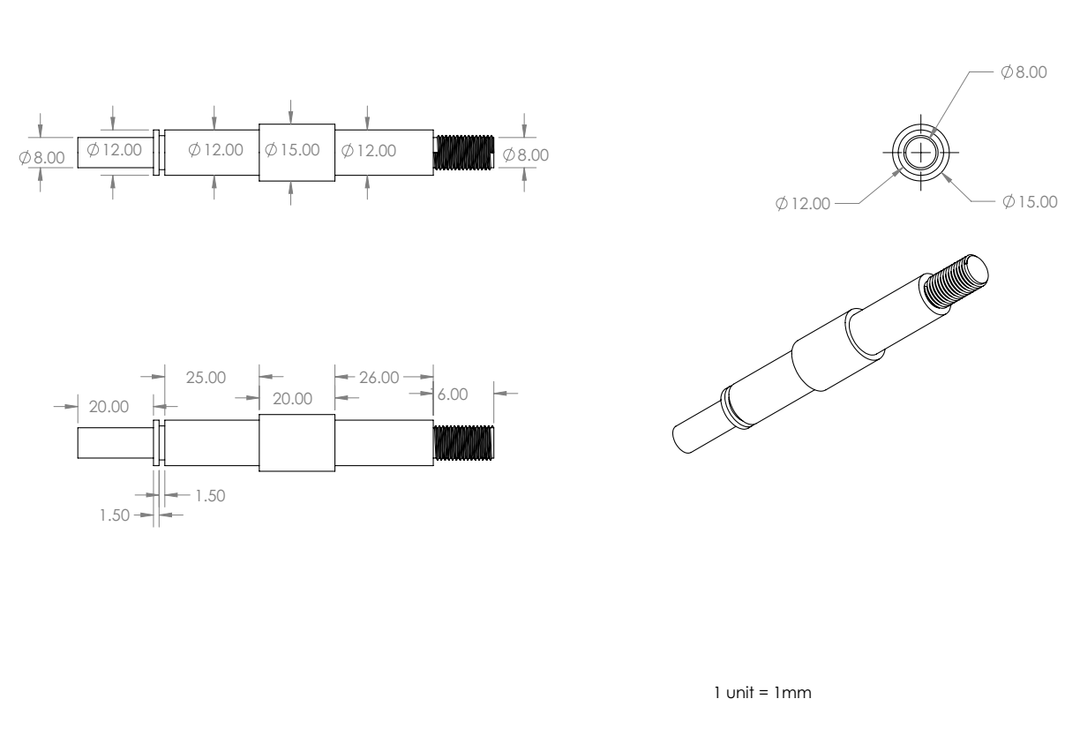

**PROCESS SHEET**

|  |  |
| --- | --- |
| **Part Name:** Bearing Housing | **Material:** Aluminium |
| **Stock Size:** | **Checked By:** |
| **Prepared By:** | **Date:** |

|  |  |  |  |  |  |
| --- | --- | --- | --- | --- | --- |
| **S. No.** | **Machine** | **Operation Description** | **Machine/Tool required** | **Operation time (min)** | **Credit** |
| 1. | Vertical Milling Centre | Clamp the workpiece and set the machine | - | 20 | 30 |
| 2. | Face milling -Finish on the top surface. | Milling machine /face mill cutter | 10 | 30 |
| 3. | End milling-Finish the sides of block | End mill cutter | 20 | 30 |
| 3. | Face milling – finish on the bottom surface | Milling machine / face mill cutter | 10 | 30 |
| 4. | Drill a pilot hole for a large through hole 8 mm. | VMC / drill press (dia -8mm) | 10 | 20 |
| 5. | Drill through hole 15 mm | VMC / drill press (dia -15mm) | 10 | 20 |
| 6. | Drill through hole 18 mm | VMC / drill press (dia -18mm) | 10 | 20 |
| 7. | End milling large counter bore (dia - 24 mm). | VMC / milling machine , end mill (dia -24mm) | 10 | 20 |
| 8. | (For opposite face)  Drill pilot hole for large through hole 8 mm. | VMC / drill press (dia -8mm) | 10 | 20 |
| 9. | Drill through hole 18 mm | VMC / drill press (dia -18mm) | 10 | 20 |
| 10. | End milling a large counterbore (diameter - 24 mm). | VMC / milling machine , end mill (dia -24mm) | 10 | 20 |
| 11. | Drill tap hole for M5 internal thread ( first drill 4.2 mm , 4 holes). | VMC / drill press (dia -4.2mm) | 10 | 40 |
| 12. | Tap internal thread M5 (4 holes ). | VMC/ tapping machine, M5 tap | 10 | 20 |

\***For measurement, Vernier Calipers are used.**

Learning outcome:

* Proper use of marking and hand tools
* Workpiece alignment
* How to use VMC?
* Face milling
* End milling
* Drilling and tapping

Student Signature: ____________________

