**FABRICATION SHOP JOB PROCESS SHEET**

|  |  |
| --- | --- |
| **Part Name:** DC motor mounting bracket | **Material:** Mild Steel |
| **Stock Size:** 300*250*2 mm | **Checked By:** |
| **Prepared By:** | **Date:** ……04/07/2025 |

|  |  |  |  |  |
| --- | --- | --- | --- | --- |
| **S. No.** | **Operation Description** | **Machine/Tool required** | **Operation time (min)** | **Credit** |
| 1. | Mark the dimensions of the base plate (50*50 mm), arm (86*40 mm), and holes of diameter (3 mm on the vertical arm and 4 mm on the base) on the raw material. | Scriber, steel rule, and try square | 15 | 20 |
| 2. | Cut all the parts to the required dimensions. | Power cutter | 15 | 20 |
| 3. | File the edges of the workpiece. | Smooth-cut hand file | 20 | 30 |
| 4. | Center punch all the marked hole positions on the workpiece. | Center punch tool and ball peen hammer | 15 | 30 |
| 5. | Drill hole of ø13 mm on top portion of the workpiece for making the slot of 13 mm length for DC motor mounting. | Drill machine with HSS drill bits | 20 | 40 |
| 6. | Drill holes of ø3 mm and ø4 mm on the vertical part and horizontal part of the arm.  File the hole surface to remove sharp edges. | Drill machine with HSS drill bits and round files | 15 | 20 |
| 7. | Make a circular arc of ø40 mm on the top of the vertical part of the arm and file the edges. | Power cutter and Bench grinder | 15 | 30 |
| 8. | Mark 40 mm from the base of the plate and bend it at an angle of 90°. | Manual bending machine, Try square | 10 | 20 |
| 9. | Make the internal threads of the required dimensions for M3 and M4 screws (in drilled holes).  Grind the outer surface to meet the dimensions of the end product. | Tapered, intermediate, and bottoming taps, grinding the outer surface | 35 | 50 |
| 10. | Fix the vertical arm to the base using screws, nuts and washers. | Screwdriver | 10 | 20 |
| 11. | Insert the dummy DC motor into the bracket hole and tighten all components. | Screwdriver | 10 | 20 |

**Learning Outcomes**

* Reading and Interpreting Engineering Drawings.
* Drilling and hole alignment.
* Sheet Metal Bending
* Threading
* **Mastery of basic hand tools**: Files, hacksaws, chisels, hammers, punches, etc.
* Understanding of **workplace safety practices**, tool maintenance, and protective gear usage.

Student Signature: ____________________

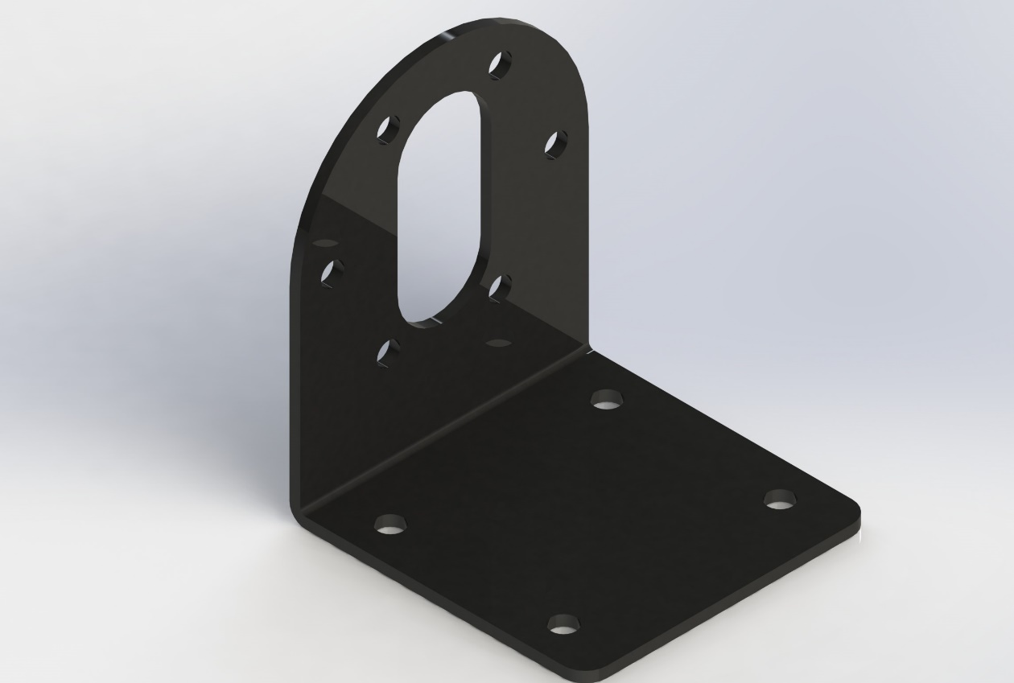

**Figure 1.** Isometric view of the DC motor mounting bracket.

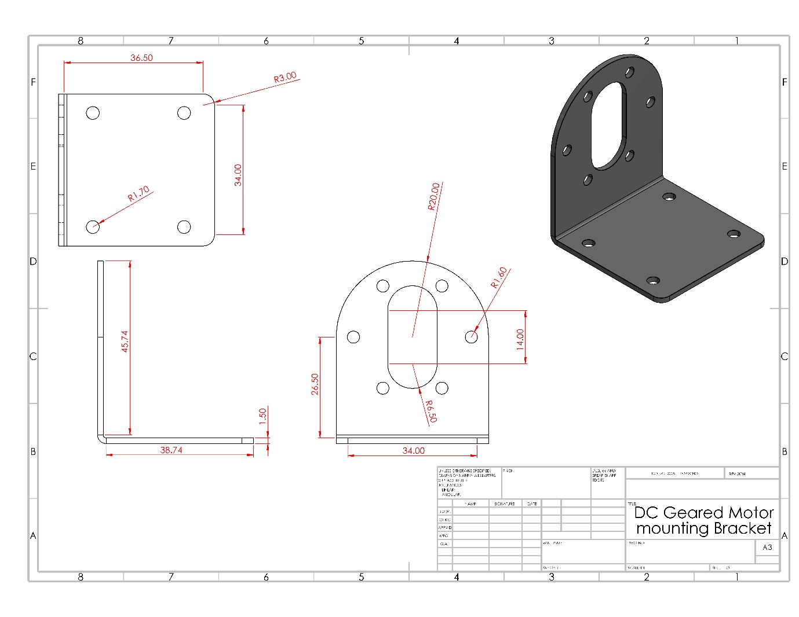

**Figure 2.** 2D representation of the DC motor mounting bracket.