**PROCESS SHEET FOR CNC LATHE**

|  |  |
| --- | --- |
| **Part Name:** Motor Coupler Shaft | **Material:** Mild Steel |
| **Stock Size:** 20 mm dia. & 130 mm length | **Checked By:** |
| **Prepared By:** | **Date:** |

|  |  |  |  |  |  |
| --- | --- | --- | --- | --- | --- |
| **S. No.** | **Machine** | **Operation Description** | **Machine/Tool required** | **Operation time**  **(min)** | **Credit** |
| **1** | CNC lathe  Lathe | Design of part, generation of codes and simulation | Inventor | 30 | 50 |
| **2** | Machine and workpiece set up and referencing | CNC Lathe | 15 | 30 |
| 3 | Facing | CNC Lathe / Single point cutting tool | 10 | 20 |
| 4 | Turning of the piece from 20 mm dia. to 15 mm dia. | CNC Lathe / Single point cutting tool | 30 | 20 |
| 5 | Turning of the w/p from 15 mm dia. to 8 mm dia. for 0 mm to 20 mm in length. | CNC Lathe / Single point cutting tool | 20 | 20 |
| 6 | Turning of the w/p from 15 mm dia. to 12 mm dia. for 20 mm to 48 mm in length. | CNC Lathe / Single point cutting tool | 15 | 20 |
| 7 | Grooving of the w/p from 12 mm dia. to 9 mm dia. for 21.5 mm to 23 mm in length. | CNC Lathe / grooving tool | 15 | 30 |
| 8 | Turning of the w/p from 15 mm dia. to 11 mm dia. For 68 mm to 94 mm in length. | CNC Lathe / Single point cutting tool | 15 | 20 |
| 9 | Turning of the w/p from 15 mm dia. to 8 mm dia.(approx.), 94 mm to 110 mm in length. | CNC Lathe / Single point cutting tool | 30 | 20 |
| 10 | Threading M8 | CNC Lathe / Single point cutting tool | 20 | 20 |

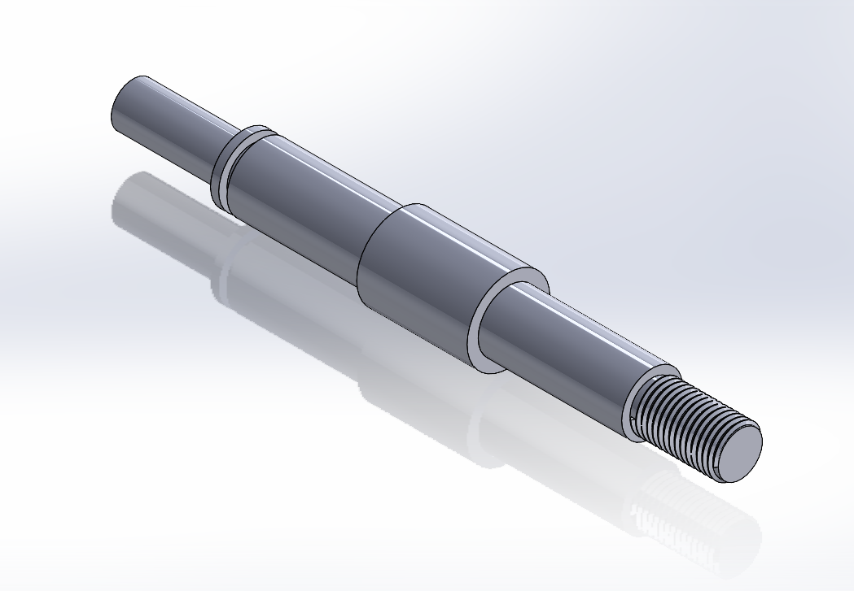

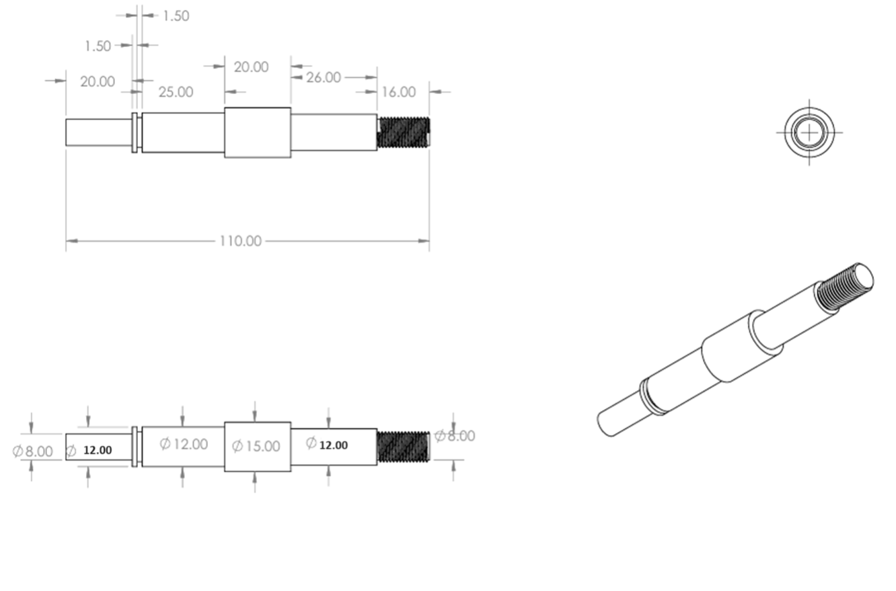

**Learning Outcomes**

* Designing of product.
* Generation of G&M code
* Workpiece alignment and referencing
* Operations like: Facing, Turning, Step turning, Grooving, Threading etc.